| ***Create a Spring Web Project using Maven*** |
| --- |

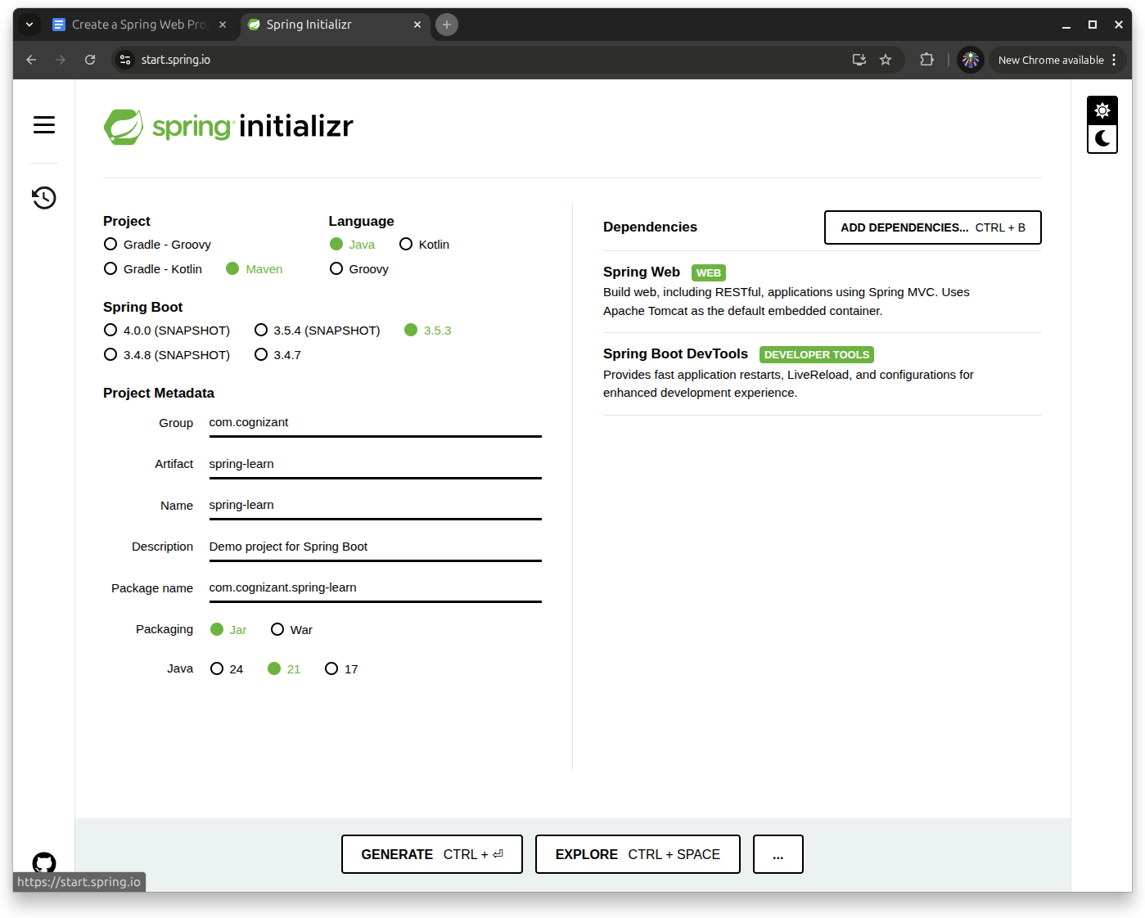

Go to [Spring initializr](https://start.spring.io/) website and choose appropriate configuration to make sure the project goes as we want it to.

1. Group as “com.cognizant”
2. Artifact Id as “spring-learn”

Extracted the zip in the appropriate location ->?

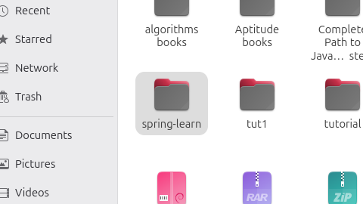

Open the extracted file inside the editor

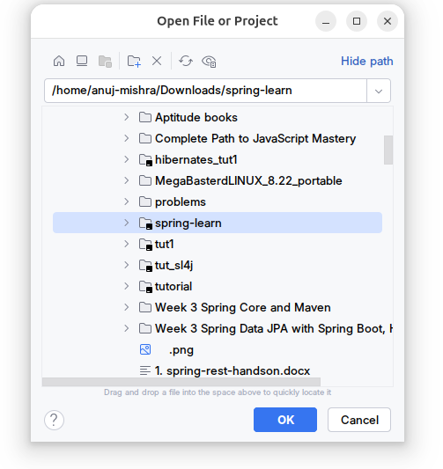

Project window would be opened as follows - >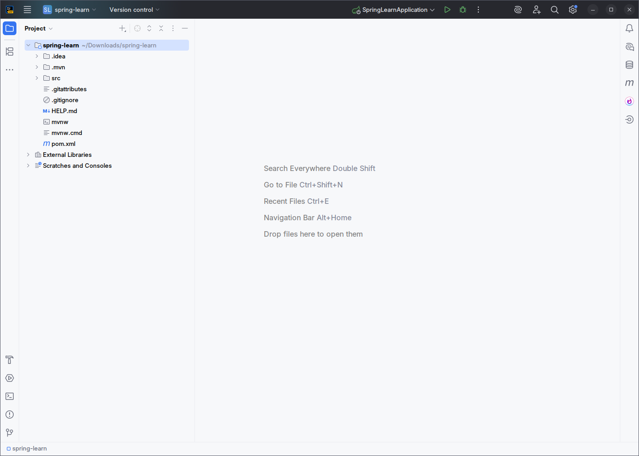

Built the project using the following command : **mvn clean package -Dhttp.proxyHost=proxy.cognizant.com -Dhttp.proxyPort=6050 -Dhttps.proxyHost=proxy.cognizant.com -Dhttps.proxyPort=6050 -Dhttp.proxyUser=123456**

Ensuring there is regular space between the cmdlets and the build was successful without errors.

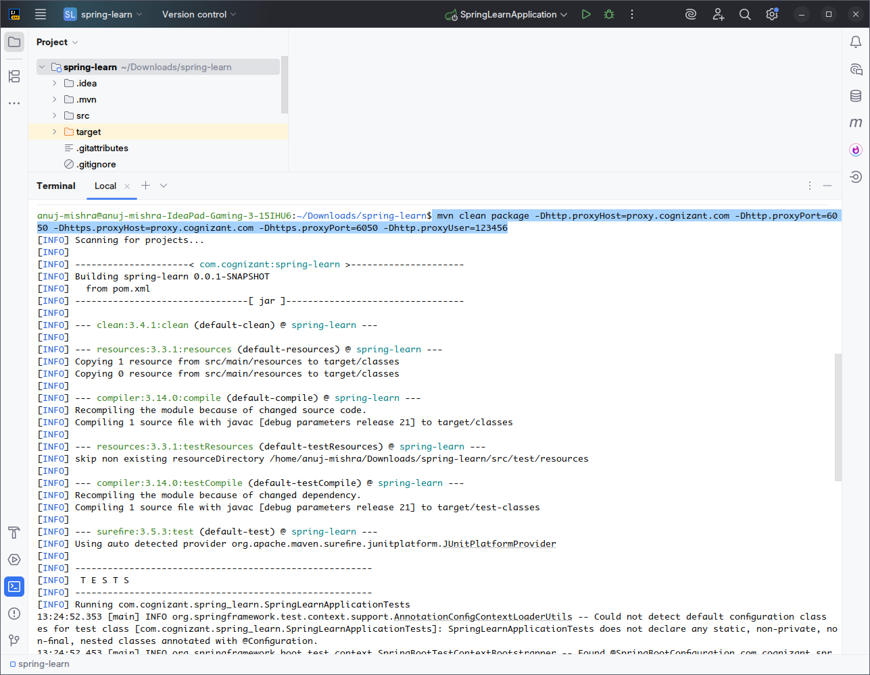

The dependencies added are as follows :

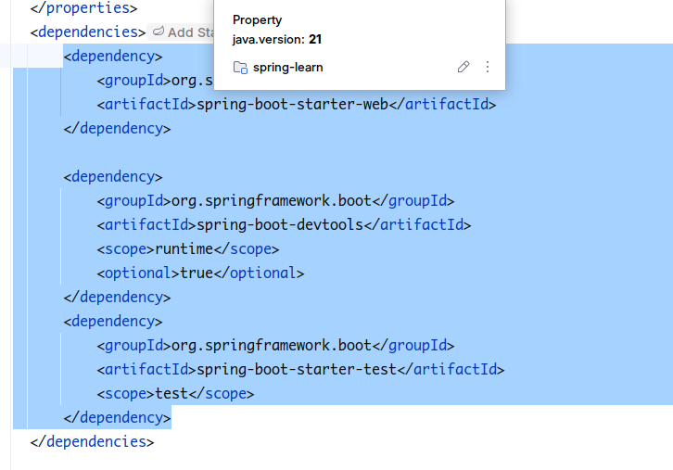

**spring-boot-starter-web → For REST APIs & web apps.**

**spring-boot-starter-test → For JUnit/Mockito testing.**

Spring Boot DevTools is a developer productivity tool that provides:

✔ Automatic Restart → Updates code changes without manual restart.

✔ Live Reload → Browser auto-refresh for static resources (HTML/JS/CSS).

✔ Developer-Friendly Defaults → Better logging, disabled caching, etc.

Added logger objects to surround the main method of **SpringLearnApplication**

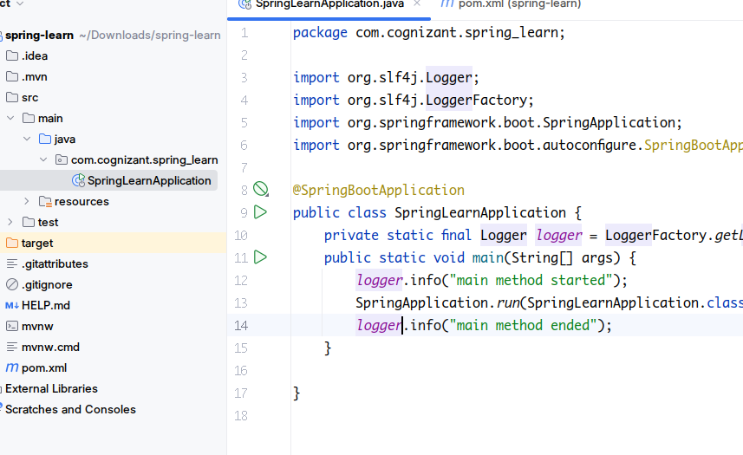

The loggers print the debug message to verify that main method started and

ended.

